**Queena Lin**

**CIS 310 Final Exam**

Use the Case ElieVideo startup company's ERD diagram on page 433 (Figure P8.47) to write SQL code to create the table structures for entities shown in Figure P8.47 and use data depicted in tables from P.8.48A to 8.48F to answer questions: 47, 48, 49, 50, and 51. Once you are finished with each problem, screenshot your result into Word, under a neat format depicting the correct problem number.

I also would like for you to create a relational diagram depicting the tables shown in Figure P8.47.

Upon completion of all tasks, please submit the followings:

1) Your SQL codes

2) Screenshot of your query results depicting the creation of 6 tables with data showed on pages 434-436 along with any updates that you generated from your responses to questions 49-51.

3) Your relational diagram

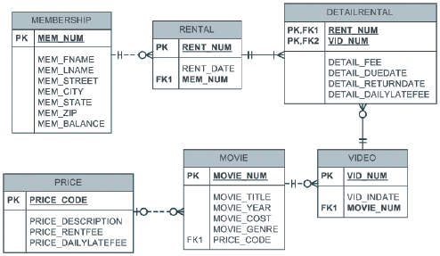

**RELATIONAL DIAGRAM**

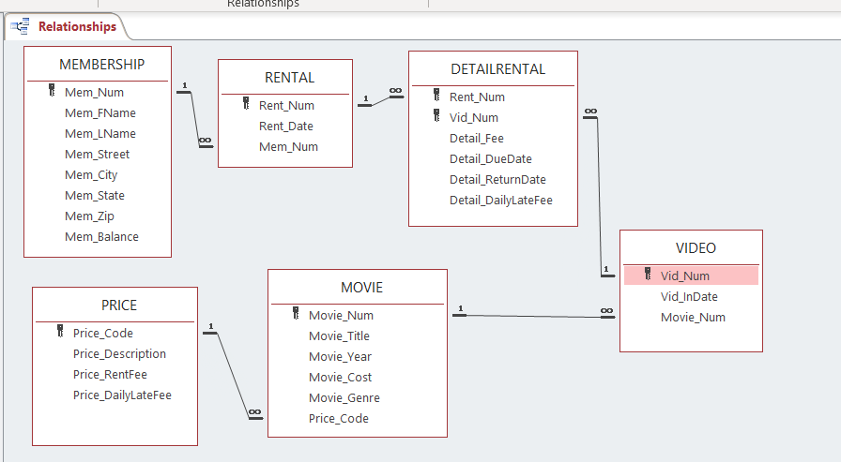

47. Write the SQL code to create the table structures for the entities shown in Figure P8.47. The structures should contain the attributes specified in the ERD. Use data types that are appropriate for the data that will need to be stored in each attribute. Enforce primary key and foreign key constraints as indicated by the ERD.

CREATE TABLE **MEMBERSHIP** (

MEM_NUM VARCHAR(15) NOT NULL,

MEM_FNAME VARCHAR(15),

MEM_LNAME VARCHAR(15),

MEM_STREET VARCHAR(50),

MEM_CITY VARCHAR(15),

MEM_STATE VARCHAR(15),

MEM_ZIP VARCHAR(15),

MEM_BALANCE DECIMAL(5,2),

PRIMARY KEY(MEM_NUM));

CREATE TABLE **PRICE**(

PRICE_CODE VARCHAR(15) NOT NULL,

PRICE_DESCRIPTION VARCHAR(100),

PRICE_RENTFEE DECIMAL(5,2),

PRICE_DAILYLATEFEE DECIMAL(5,2),

PRIMARY KEY(PRICE_CODE));

CREATE TABLE **RENTAL**(

RENT_NUM VARCHAR(15) NOT NULL,

RENT_DATE DATETIME,

MEM_NUM VARCHAR(15),

PRIMARY KEY(RENT_NUM),

FOREIGN KEY(MEM_NUM) **REFERENCES** MEMBERSHIP(MEM_NUM));

CREATE TABLE **VIDEO** (

VID_NUM VARCHAR(15) NOT NULL,

VID_INDATE DATETIME,

MOVIE_NUM VARCHAR(15),

PRIMARY KEY (VID_NUM));

CREATE TABLE **MOVIE** (

MOVIE_NUM VARCHAR(15) NOT NULL,

MOVIE_TITLE VARCHAR(50),

MOVIE_YEAR VARCHAR(15),

MOVIE_COST DECIMAL(5,2),

MOVIE_GENRE VARCHAR(15),

PRICE_CODE VARCHAR(15),

PRIMARY KEY(MOVIE_NUM),

FOREIGN KEY (PRICE_CODE) **REFERENCES** PRICE(PRICE_CODE));

CREATE TABLE **DETAILRENTAL** (

RENT_NUM VARCHAR(15) NOT NULL,

VID_NUM VARCHAR(15) NOT NULL,

DETAIL_FEE DECIMAL(5,2),

DETAIL_DUEDATE DATETIME,

DETAIL_RETURNDATE DATETIME,

DETAIL_DAILYLATEFEE DECIMAL,

PRIMARY KEY(RENT_NUM, VID_NUM),

FOREIGN KEY(RENT_NUM) **REFERENCES** RENTAL(RENT_NUM),

FOREIGN KEY(VID_NUM) **REFERENCES** VIDEO(VID_NUM));

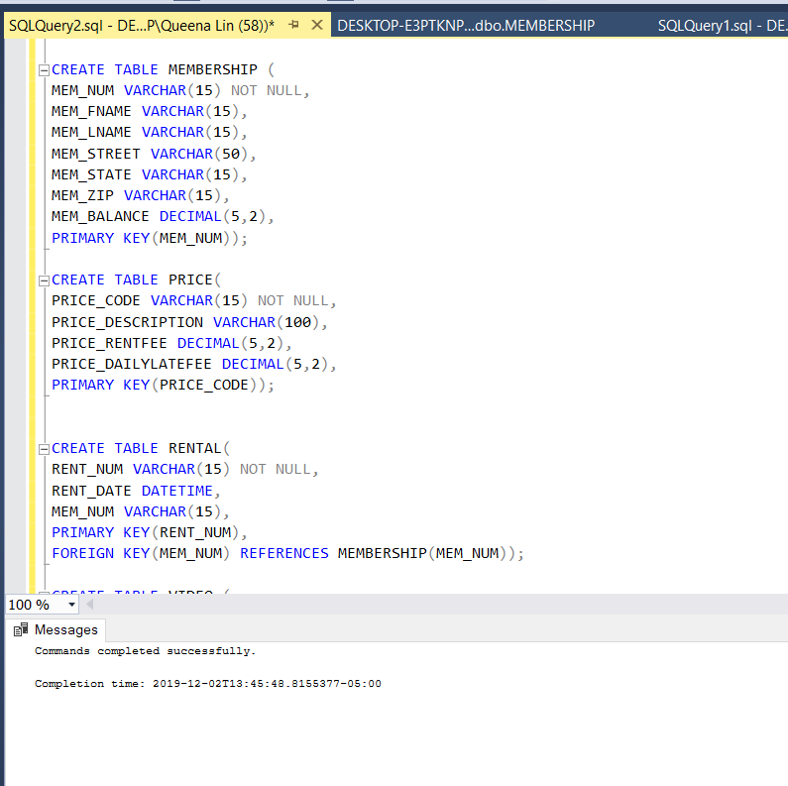

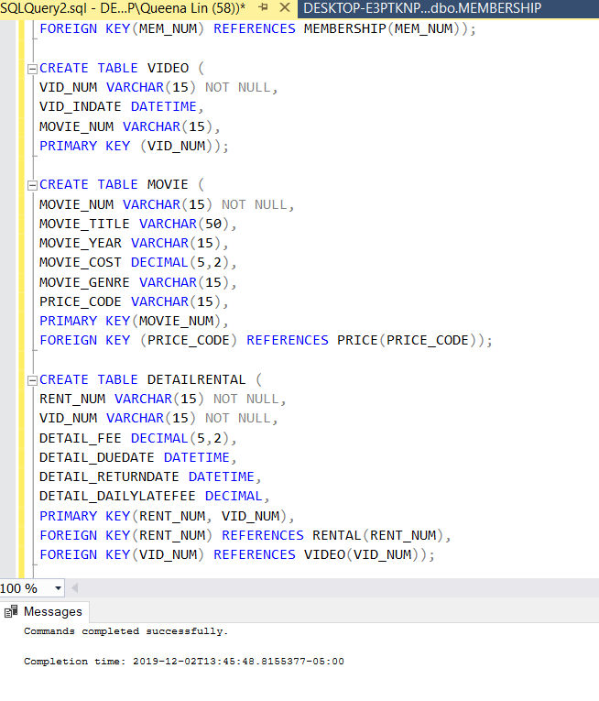

48. The following tables provide a very small portion of the data that will be kept in the database. The data needs to be inserted into the database for testing purposes. Write the INSERT commands necessary to place the following data in the tables that were created in Problem 47. (If required by your DBMS, be certain to save the rows permanently.)

**BEGIN TRANSACTION**

INSERT INTO **MEMBERSHIP** VALUES('102','Tami','Dawson', '2632 Takli Circle','Norene','TN','37136',11);

INSERT INTO **MEMBERSHIP** VALUES('103','Curt','Knight', '4025 Cornell Court','Flatgap','KY','41219',6);

INSERT INTO **MEMBERSHIP** VALUES('104','Jamal','Melendez', '6045 Musket Ball Circle','Queback','TN','38579',01);

INSERT INTO **MEMBERSHIP** VALUES('105','Iva','Mcclain', '4469 Maxwell Place','Summit','KY','42783',15);

INSERT INTO **MEMBERSHI**P VALUES('106','Miranda','Parks', '2632 Takli Circle','Germantown','TN','38183',0);

INSERT INTO **MEMBERSHIP** VALUES('107','Rosario','Elliot', '7578 Danner Avenue','Columbia','TN','38402',5);

INSERT INTO **MEMBERSHIP** VALUES('108','Mattie','Guy', '4390 Evergreen Street','Lily','KY','40740',0);

INSERT INTO **MEMBERSHIP** VALUES('109','Clint','Ochoa', '1711 Elm Street','Greeneville','TN','37745',10);

INSERT INTO **MEMBERSHIP** VALUES('110','Lewis','Rosales', '4524 Southwind Circle','Counce','TN','38326',0);

INSERT INTO **MEMBERSHIP** VALUES('111','Stacy','Mann', '2789 East Cook Avenue','Murfreesbor','TN','37132',8);

INSERT INTO **MEMBERSHIP** VALUES('112','Luis','Trujillo', '7267 Melvin Avenue','Heiskell','TN','37754',3);

INSERT INTO **MEMBERSHIP** VALUES('113','Minnie','Gonzales', '6430 Vasili Drive','Williston','TN','38076',0);

INSERT INTO **PRICE** VALUES('1','Standard',2,1);

INSERT INTO **PRICE** VALUES('2','New Release',3.5,3);

INSERT INTO **PRICE** VALUES('3','Discount',1.5,1);

INSERT INTO **PRICE** VALUES('4','Weekly Special',1,0.5);

INSERT INTO **RENTAL** VALUES('1001','01-MAR-18','103');

INSERT INTO **RENTAL** VALUES('1002','01-MAR-18','105');

INSERT INTO **RENTAL** VALUES('1003','02-MAR-18','102');

INSERT INTO **RENTAL** VALUES('1004','02-MAR-18','110');

INSERT INTO **RENTAL** VALUES('1005','02-MAR-18','111');

INSERT INTO **RENTAL** VALUES('1006','02-MAR-18','107');

INSERT INTO **RENTAL** VALUES('1007','02-MAR-18','104');

INSERT INTO **RENTAL** VALUES('1008','01-MAR-18','105');

INSERT INTO **RENTAL** VALUES('1009','01-MAR-18','111');

INSERT INTO **VIDEO** VALUES('54321','18-JUN-17','1234')

INSERT INTO **VIDEO** VALUES('54324','18-JUN-17','1234');

INSERT INTO **VIDEO** VALUES('54325','18-JUN-17','1234');

INSERT INTO **VIDEO** VALUES('34341','22-JAN-16','1235');

INSERT INTO **VIDEO** VALUES('34342','22-JAN-16','1235');

INSERT INTO **VIDEO** VALUES('34366','02-MAR-18','1236');

INSERT INTO **VIDEO** VALUES('34367','02-MAR-18','1236');

INSERT INTO **VIDEO** VALUES('34368','02-MAR-18','1236');

INSERT INTO **VIDEO** VALUES('34369','02-MAR-18','1236');

INSERT INTO **VIDEO** VALUES('44392','21-OCT-17','1237');

INSERT INTO **VIDEO** VALUES('44397','21-OCT-17','1237');

INSERT INTO **VIDEO** VALUES('59237','14-FEB-18','1237');

INSERT INTO **VIDEO** VALUES('61388','25-JAN-16','1238');

INSERT INTO **VIDEO** VALUES('61353','28-JAN-15','1245');

INSERT INTO **VIDEO** VALUES('61354','28-JAN-15','1245');

INSERT INTO **VIDEO** VALUES('61367','30-JUL-17','1246');

INSERT INTO **VIDEO** VALUES('61369','30-JUL-17','1246');

INSERT INTO **MOVIE** VALUES('1234','The Cesar Family Christmas','2016',39.95, 'FAMILY',2);

INSERT INTO **MOVIE** VALUES('1235','Smokey Mountain Wildlife','2013',59.95, 'ACTION',1);

INSERT INTO **MOVIE** VALUES('1236','Richard Goodhope','2017',59.95, 'DRAMA',2);

INSERT INTO **MOVIE** VALUES('1237','Beanik Fever','2016',29.95, 'COMEDEY',2);

INSERT INTO **MOVIE** (MOVIE_NUM, MOVIE_TITLE, MOVIE_YEAR, MOVIE_COST, MOVIE_GENRE) VALUES('1238','Constant Companion','2017',89.95, 'DRAMA');

INSERT INTO **MOVIE** VALUES('1239','Where Hope Dies','2007',25.49, 'DRAMA',3);

INSERT INTO **MOVIE** VALUES('1245','Time to Burn','2014',45.49, 'ACTION',1);

INSERT INTO **MOVIE** VALUES('1246','What He Doesnt Know','2015',58.29, 'COMEDY',1);

INSERT INTO **DETAILRENTAL** (RENT_NUM, VID_NUM, DETAIL_FEE,DETAIL_DUEDATE, DETAIL_RETURNDATE) VALUES('1001','34342',2,'04-MAR-18','02-MAR-18');

INSERT INTO **DETAILRENTAL** VALUES('1001','61353',2,'04-MAR-18','03-MAR-18',1);

INSERT INTO **DETAILRENTAL** VALUES('1002','59237',3.5,'04-MAR-18','04-MAR-18',3);

INSERT INTO **DETAILRENTAL** VALUES('1003','54325',3.5,'04-MAR-18','09-MAR-18',3);

INSERT INTO **DETAILRENTAL** VALUES('1003','61369',2,'06-MAR-18','09-MAR-18',1);

INSERT INTO **DETAILRENTAL** VALUES('1003','61388',0,'06-MAR-18','09-MAR-18',1);

INSERT INTO **DETAILRENTAL** VALUES('1004','44392',3.5,'05-MAR-18','07-MAR-18',3);

INSERT INTO **DETAILRENTAL** VALUES('1004','34367',3.5,'05-MAR-18','07-MAR-18',3);

INSERT INTO **DETAILRENTAL** VALUES('1004','34341',2,'07-MAR-18','07-MAR-18',1);

INSERT INTO **DETAILRENTAL** VALUES('1005','34342',2,'07-MAR-18','05-MAR-18',1);

INSERT INTO **DETAILRENTAL** VALUES('1005','44397',3.5,'05-MAR-18','05-MAR-18',3);

INSERT INTO **DETAILRENTAL** VALUES('1006','34366',3.5,'05-MAR-18','04-MAR-18',3);

INSERT INTO **DETAILRENTAL** (RENT_NUM, VID_NUM, DETAIL_FEE,DETAIL_DUEDATE, DETAIL_DAILYLATEFEE) VALUES('1006','61367',2,'07-MAR-18',1);

INSERT INTO **DETAILRENTAL** (RENT_NUM, VID_NUM, DETAIL_FEE,DETAIL_DUEDATE, DETAIL_DAILYLATEFEE) VALUES('1007','34368',3.5,'05-MAR-18',3);

INSERT INTO **DETAILRENTAL** VALUES('1008','34369',3.5,'05-MAR-18','05-MAR-18',3);

INSERT INTO **DETAILRENTAL** (RENT_NUM, VID_NUM, DETAIL_FEE,DETAIL_DUEDATE, DETAIL_DAILYLATEFEE)VALUES('1009','54324',3.5,'05-MAR-18',3);

INSERT INTO **DETAILRENTAL** VALUES('1001','34366',3.5,'04-MAR-18','02-MAR-18',3);

**COMMIT;**

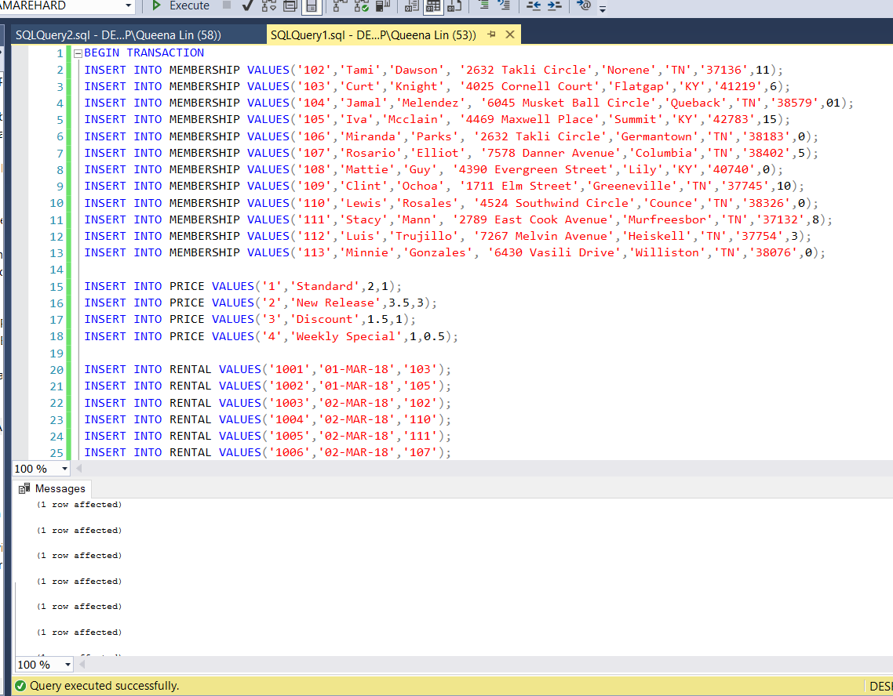

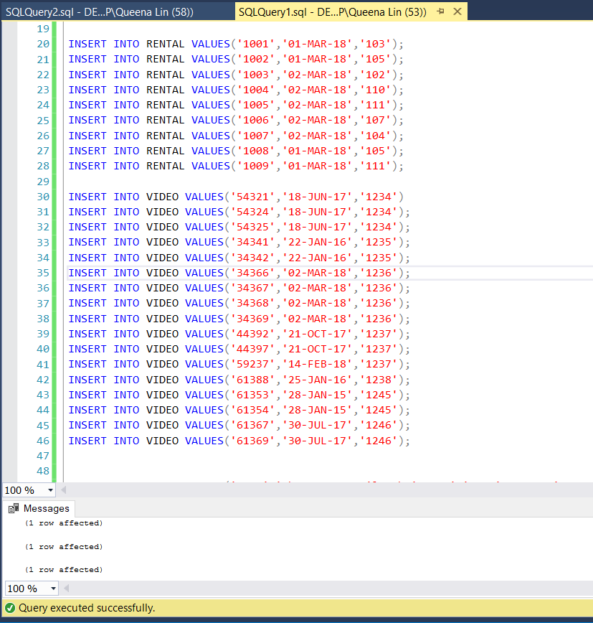

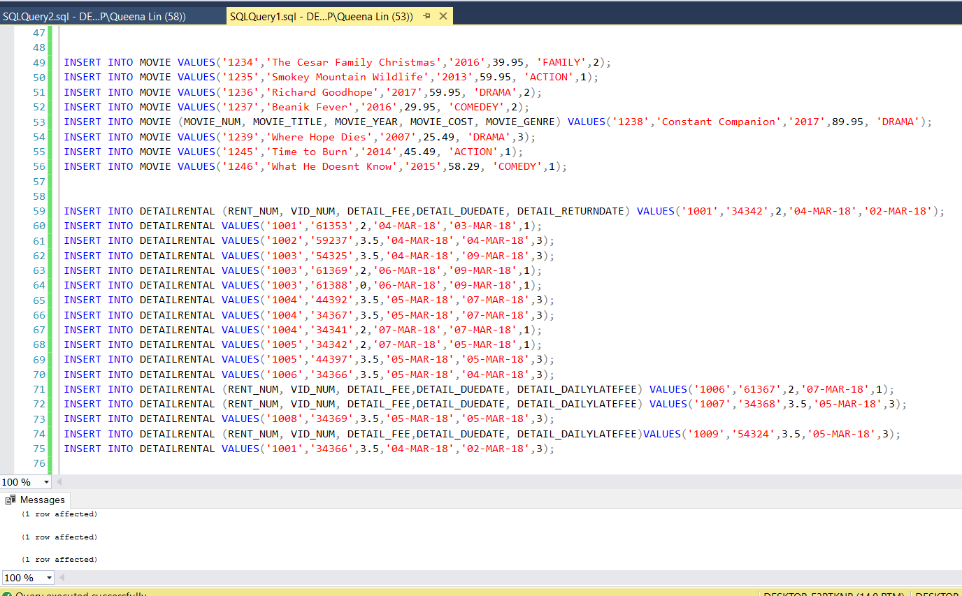

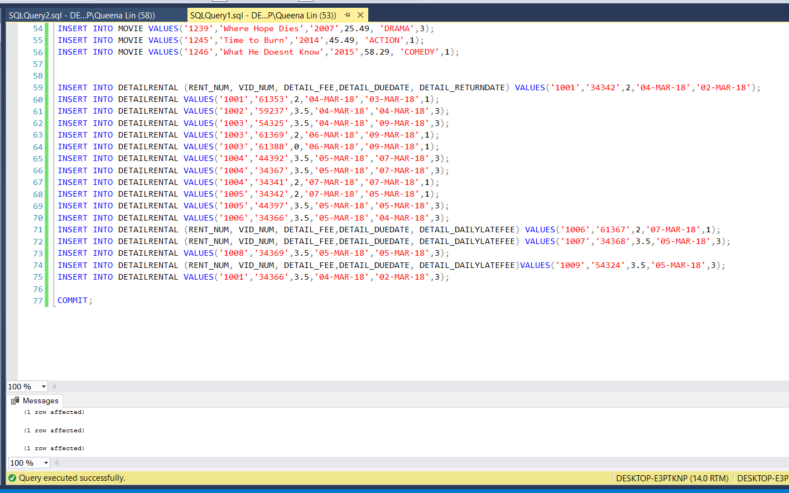

49. Write the SQL command to change the movie year for movie number 1245 to 2014.

UPDATE MOVIE

SET MOVIE_YEAR = '2014'

WHERE MOVIE_NUM = 1245;

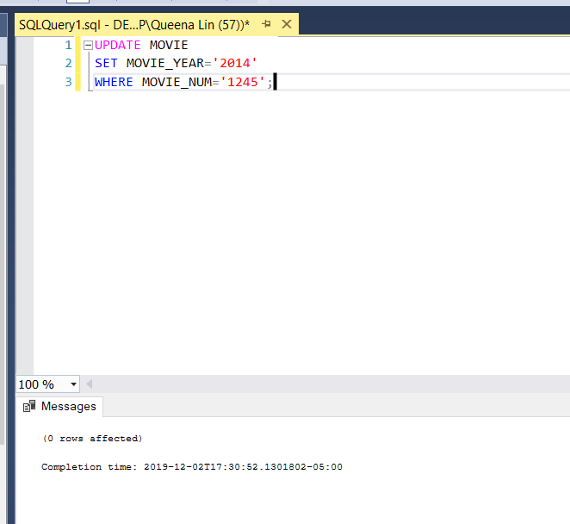

50. Write the SQL command to change the price code for all action movies to price code 3.

UPDATE MOVIE

SET PRICE_CODE = '3'

WHERE MOVIE_GENRE = 'ACTION' ;

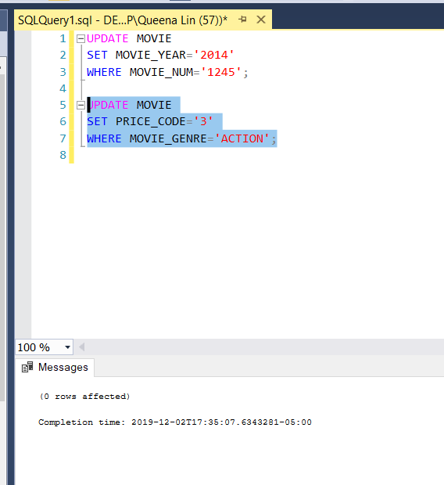

51. Write a single SQL command to increase all price rental fee values in the PRICE table by $0.50.

UPDATE PRICE

SET PRICE_RENTFEE = PRICE_RENTFEE + 0.50;

